A project report on
PHYSICS-INFORMED DEEP NEURAL NETWORK FOR DIGITAL TWIN MODELING OF UAV-TO-GROUND WIRELESS CHANNELS
submitted in partial fulfilment of the requirements for the course
MACHINE LEARNING
25SC2107E
A.Y.: 2026–27
S. HARSHITHA 2520040017
P. SRINIDHI 2520040016

UNDER THE ESTEEMED GUIDANCE OF
MR. N. LAVA PRASAD
Assistant Professor
DEPARTMENT OF ELECTRONICS & COMMUNICATION ENGINEERING
KL UNIVERSITY, HYDERABAD



ABSTRACT
Unmanned Aerial Vehicles (UAVs) are increasingly used for surveillance, emergency response, smart-city services, and temporary wireless coverage. Their air-to-ground radio channels change with altitude, horizontal separation, carrier frequency, line-of-sight probability, and environmental obstructions. This report presents a software-based Digital Twin that predicts UAV-to-ground path loss using a conventional Deep Neural Network (DNN) and a Physics-Informed Deep Neural Network (PI-DNN).
The implementation uses a simulated suburban channel generated from Free-Space Path Loss (FSPL), an elevation-dependent line-of-sight probability, LoS/NLoS excess-loss terms, and Gaussian shadowing in the labelled training samples. Both models use three inputs—UAV altitude, horizontal distance, and carrier frequency—and predict path loss in decibels. The DNN is trained using data loss, while the PI-DNN adds propagation constraints to encourage distance scaling, frequency scaling, and a free-space lower bound.
In the default Progress Review 2 experiment, the models were trained on 150 noisy labelled samples and evaluated on 400 labelled-region points and 600 points outside the labelled region. The PI-DNN achieved 0.87 dB RMSE on unseen points compared with 7.77 dB for the DNN. Across six random seeds, mean unseen-region RMSE was reported as 0.80 dB for PI-DNN and 15.76 dB for DNN. These values are simulation results, not field measurements; because the physics penalties align with the simulator's free-space core, real-world validation remains necessary.
Keywords: UAV-to-ground channel, Physics-Informed Neural Network, Deep Neural Network, Free-Space Path Loss, Digital Twin, wireless propagation.

INDEX
SECTION | PAGE
ABSTRACT | ii
1. INTRODUCTION | 1
2. LITERATURE SURVEY AND RESEARCH GAP | 2
3. SYSTEM MODEL AND ARCHITECTURE | 3
4. PROPOSED METHODOLOGY | 4
5. IMPLEMENTATION DETAILS | 5
6. EXPERIMENTAL SETUP | 6
7. RESULTS: LABELLED AND UNSEEN REGIONS | 7
8. ROBUSTNESS AND PHYSICS-WEIGHT ANALYSIS | 8
9. DIGITAL TWIN AND SCENARIO STUDY | 9
10. DISCUSSION AND LIMITATIONS | 10
11. CONCLUSION AND FUTURE WORK | 11
REFERENCES | 12

1. INTRODUCTION

1.1 Background
UAVs can act as mobile communication nodes, aerial relays, or temporary access points. In an air-to-ground link, the UAV's altitude and horizontal separation determine the three-dimensional distance and elevation angle. These geometric factors influence the chance of a clear line-of-sight path. Buildings, trees, terrain, antenna patterns, and multipath can introduce additional attenuation and variation.
A Digital Twin is a software representation of a real or conceptual system that allows scenarios to be explored without repeating every physical experiment. In this project, the twin represents a UAV, a ground station, and the radio channel between them. A user can change altitude, horizontal distance, carrier frequency, and transmit power and immediately observe predicted path loss, estimated received power, and a threshold-based link-quality label.

1.2 Problem Statement
A purely data-driven model can fit observed samples but may behave unpredictably when queried beyond the region covered by its training data. Collecting real measurements for every combination of UAV position and radio frequency is expensive. The problem is to determine whether selected propagation laws, added as a physics penalty during training, can improve the physical consistency and generalization of a neural channel predictor.

1.3 Objectives
- Construct a reproducible simulated air-to-ground channel dataset with documented assumptions.
- Implement a conventional DNN baseline and a PI-DNN with a physics-informed objective.
- Evaluate both models on labelled-region and unseen-region samples using regression metrics.
- Test sensitivity to random initialization and physics-loss weight λ.
- Connect the predictions to an interactive software Digital Twin for what-if analysis.

1.4 Scope
The current study is a simulation-based proof of concept. It does not claim a live connection to a physical UAV or a completed flight measurement campaign. The results establish behaviour under the chosen simulator and physics assumptions; validation on measured or public air-to-ground data is a necessary next step.

2. LITERATURE SURVEY AND RESEARCH GAP
Air-to-ground propagation research combines geometry, empirical environment parameters, and probabilistic line-of-sight models. Neural models can approximate nonlinear relationships from examples, but their behaviour in data-sparse regions depends on the training distribution. Physics-informed learning introduces known relationships into the training objective, potentially reducing implausible extrapolation.
APPROACH | STRENGTH | LIMITATION
Free-space / empirical channel models | Interpretable; computationally efficient; expose physical dependencies. | Simplifying assumptions may not represent all urban, terrain, or multipath conditions.
Conventional machine learning | Learns patterns from labelled samples and can model nonlinear relationships. | Needs representative data; extrapolation may be unstable.
Deep Neural Network (DNN) | Flexible nonlinear function approximation. | Predictions are not automatically constrained by propagation laws.
Physics-Informed DNN (PI-DNN) | Combines data fitting with penalties for violations of selected physical rules. | Depends on correct physics, loss weighting, and meaningful evaluation.
This project | Compares DNN and PI-DNN in a Digital Twin and tests unseen operating conditions. | Current evidence is generated by a simulator, not field measurements.

2.1 Research Gap
The project focuses on a practical question: does a physics-informed objective improve predictions where labelled examples are sparse or absent? The comparison is designed so the DNN and PI-DNN use the same small labelled region, with the physics penalty as the principal training difference. The test reports both in-region accuracy and out-of-region generalization.

2.2 Research Contribution
The contribution is an integrated demonstration rather than a new propagation law: a documented simulated dataset, two comparable neural predictors, physics consistency checks, evaluation plots, and a user-facing Digital Twin. The results are interpreted with the limitation that the simulator and physics constraints share assumptions.

3. SYSTEM MODEL AND ARCHITECTURE
The implementation pipeline starts with a channel simulator and ends with an interactive view of the predicted radio link. The same model inputs are used for the DNN and PI-DNN, and the Digital Twin computes received power from transmit power and predicted path loss.
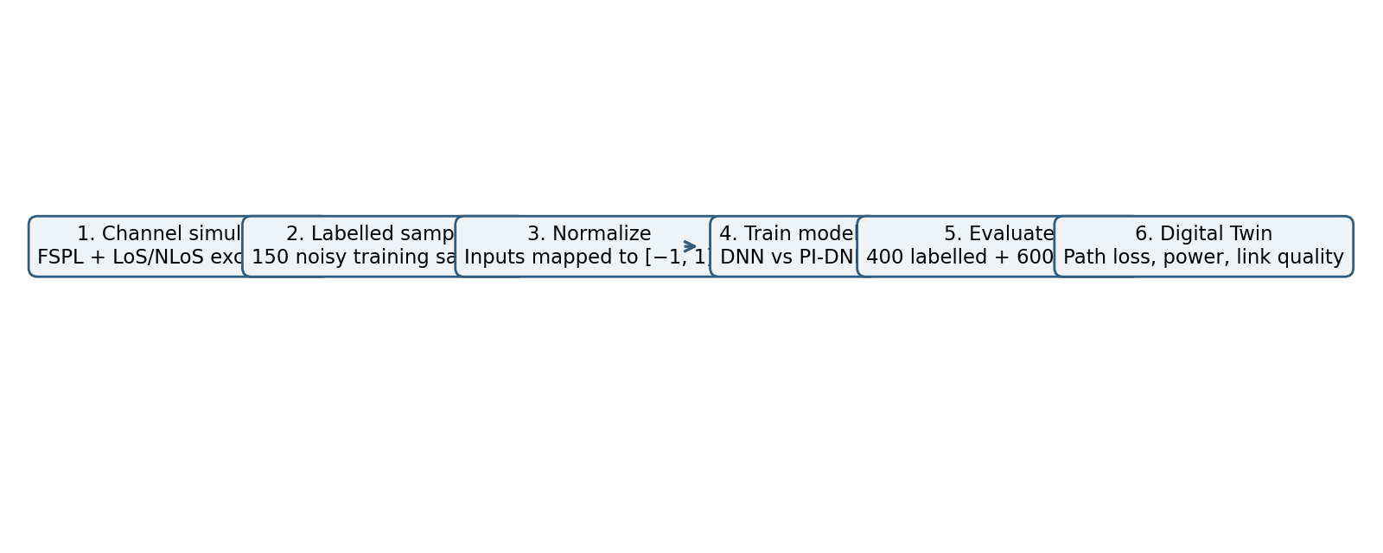
Figure 1. End-to-end workflow used in Progress Review 2.

3.1 Model Architecture
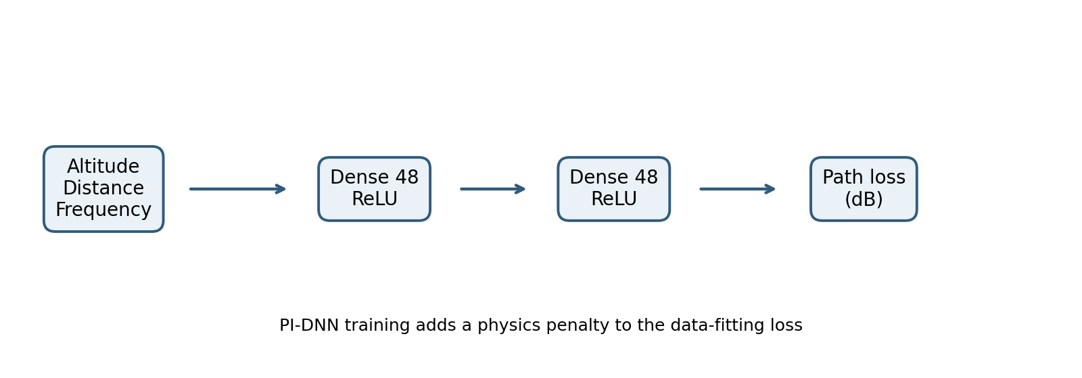
Figure 2. Neural-network architecture shared by the DNN and PI-DNN.
The network has three input features, two hidden layers of 48 neurons with ReLU activation, and one output representing path loss in dB. The conventional DNN minimizes data-fitting loss. The PI-DNN adds a physics loss evaluated at unlabelled collocation points. In the reviewed setup, the default training uses Adam, learning rate 0.004, full-batch/mini-batch implementation as described in the review, and 1,200 epochs for the headline results.

3.2 Inputs and Outputs
VARIABLE | ROLE | RANGE / UNIT
UAV altitude h | Input feature | 20–300 m full domain; labelled region 20–150 m
Horizontal distance r | Input feature | 50–2,000 m full domain; labelled region 50–800 m
Carrier frequency f | Input feature | 0.9–5.8 GHz full domain; labelled region 1.8–3.0 GHz
Transmit power Pt | Digital Twin calculation | dBm; not a network input
Path loss PL | Model output | dB
Received power Pr | Derived twin output | Pr = Pt − PL, assuming 0 dBi antennas

4. PROPOSED METHODOLOGY

4.1 Simulated Channel
The suburban channel simulator computes the three-dimensional separation d = √(h² + r²), calculates FSPL, and adds an elevation-dependent excess-loss term using a probabilistic line-of-sight model. The review specifies ηLoS = 0.1 dB and ηNLoS = 21 dB for the suburban environment. Gaussian shadowing with a standard deviation of 2 dB is added to the labelled training samples; the evaluation points are noise-free.

4.2 Free-Space Path Loss
With distance d in kilometres and frequency f in megahertz, the reference equation is:
PL_FSPL (dB) = 20 log₁₀(d) + 20 log₁₀(f) + 32.44
The 3D distance is derived from UAV altitude and horizontal distance. Units must be converted consistently before evaluating FSPL. The formula captures the increasing free-space loss with distance and carrier frequency; it does not by itself represent every obstruction or multipath effect.

4.3 Physics-Informed Objective
L_total = L_data + λ L_physics
The data term measures prediction error on labelled samples. The physics term includes three constraints used in the reviewed implementation:
- Distance law: at a constant elevation angle, scaling distance by s should add 20 log₁₀(s) dB.
- Frequency law: scaling carrier frequency by k should add 20 log₁₀(k) dB.
- Free-space floor: predicted path loss should not fall below FSPL for the applicable assumptions.
The physics penalty is evaluated at 64 random unlabelled points per epoch across the operating domain. The default physics weight is λ = 1. The weight sweep checks whether performance is sensitive to this choice.

5. IMPLEMENTATION DETAILS

5.1 Software Components
COMPONENT | IMPLEMENTATION ROLE
Channel simulator | Produces synthetic path-loss targets using FSPL, LoS probability, excess loss, and shadowing.
Data preparation | Defines a labelled training region and a wider operating domain; normalizes inputs.
DNN baseline | Three inputs → 48 ReLU → 48 ReLU → one path-loss output; trained with data loss.
PI-DNN | Uses the comparable neural model and adds the physics-consistency penalty.
Evaluation | Reports MAE, MSE, RMSE, and R² on labelled-region and unseen-region points.
Digital Twin | Lets the user vary altitude, distance, frequency, transmit power, and predictor selection.

5.2 Data Normalization and Splits
The Progress Review 2 setup uses 150 noisy labelled samples drawn from the restricted labelled region. The full evaluation consists of 400 labelled-region test points and 600 points from outside that region. The unseen test points are noise-free so that the measured error reflects prediction mismatch against the simulator rather than added test noise.
The feature scaling maps inputs to [−1, 1]. Path loss is normalized as (PL − 100) / 25 during network training and converted back to dB for reporting. Both models start from comparable initial weights to support a fair comparison. The only intended difference in objective is the physics term.

5.3 Reproducibility
The headline run uses seed 1, 150 labelled samples, λ = 1, and 1,200 epochs. The robustness experiment repeats the comparison for six random seeds. The λ sweep uses three seeds, according to the review slides. Reported metrics and chart values in this document are taken from the provided Progress Review 2 presentation.

6. EXPERIMENTAL SETUP

6.1 Parameter Regions
PARAMETER | FULL DOMAIN | LABELLED REGION | UNSEEN EVALUATION
Altitude | 20–300 m | 20–150 m | Includes higher altitudes
Horizontal distance | 50–2,000 m | 50–800 m | Includes distances beyond 800 m
Carrier frequency | 0.9–5.8 GHz | 1.8–3.0 GHz | Includes frequencies outside labelled band

6.2 Evaluation Metrics
METRIC | DEFINITION | INTERPRETATION
MAE | Mean(|y − ŷ|) | Average absolute error; lower is better.
MSE | Mean((y − ŷ)²) | Penalizes larger errors more strongly; lower is better.
RMSE | √MSE | Error in dB for path-loss prediction; lower is better.
R² | 1 − SSres/SStot | Fit relative to a mean-target baseline; closer to 1 is generally better.

6.3 Fairness and Evaluation Design
The models receive the same labelled examples and are evaluated against the same held-out sets. The comparison separates performance within the data-supported region from performance in conditions outside it. The six-seed experiment addresses variability from random initialization, while the λ sweep examines how strongly the physics term must be weighted.
The results are specific to this simulator and its assumptions. In particular, the free-space-based constraints match part of the simulator's structure. This is an important qualification when interpreting the strong unseen-region performance.

7. RESULTS: LABELLED AND UNSEEN REGIONS
The default run reports strong performance for both models inside the labelled region. The difference is much larger on unseen points: the DNN error increases substantially, whereas the PI-DNN remains close to the simulated target.
METRIC | LABELLED: DNN | LABELLED: PI-DNN | UNSEEN: DNN | UNSEEN: PI-DNN
MAE (dB) | 1.09 | 0.86 | 6.01 | 0.74
MSE (dB²) | 1.92 | 1.17 | 60.41 | 0.76
RMSE (dB) | 1.39 | 1.08 | 7.77 | 0.87
R² | 0.984 | 0.990 | 0.626 | 0.995

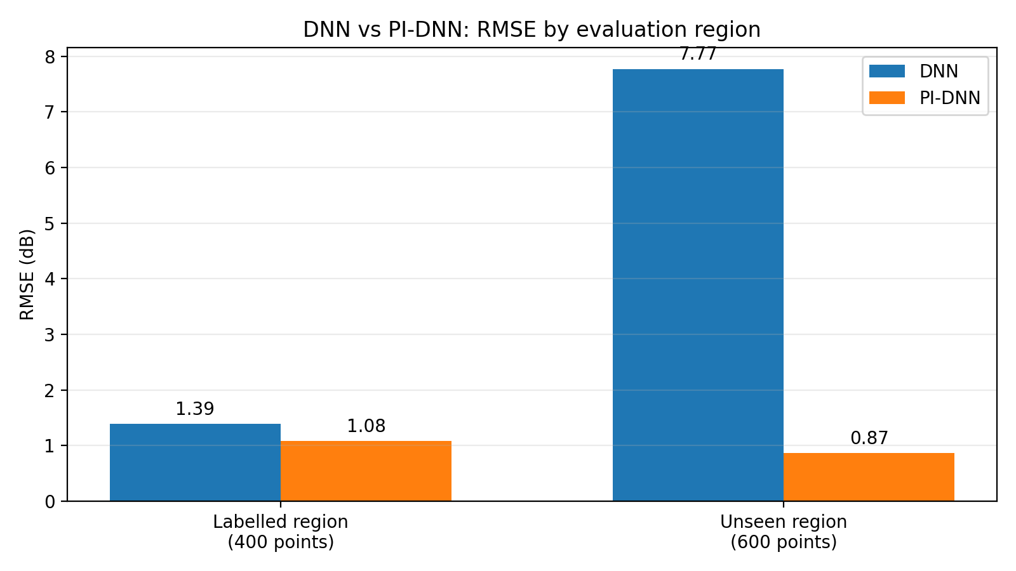
Figure 3. RMSE comparison in the labelled and unseen evaluation regions.

7.1 Interpretation
Within the labelled region, the PI-DNN reduces RMSE from 1.39 dB to 1.08 dB. On unseen points, RMSE decreases from 7.77 dB to 0.87 dB, approximately an 8.9-fold reduction. R² for the DNN drops to 0.626 on unseen points, while the PI-DNN reaches 0.995. This suggests that the physics term helps constrain extrapolation under the chosen simulated conditions.
The comparison does not establish that the PI-DNN will achieve the same improvement on real wireless channels. The unseen region is still generated by the same simulator, so the physics-informed model benefits from alignment between its constraints and the data-generation process.

8. UNSEEN-REGION GENERALIZATION
The unseen-region test is the central experiment because it asks how each model behaves when the input conditions move beyond the region represented by the labelled samples. The evaluation contains 600 noise-free points drawn from the wider operating domain.
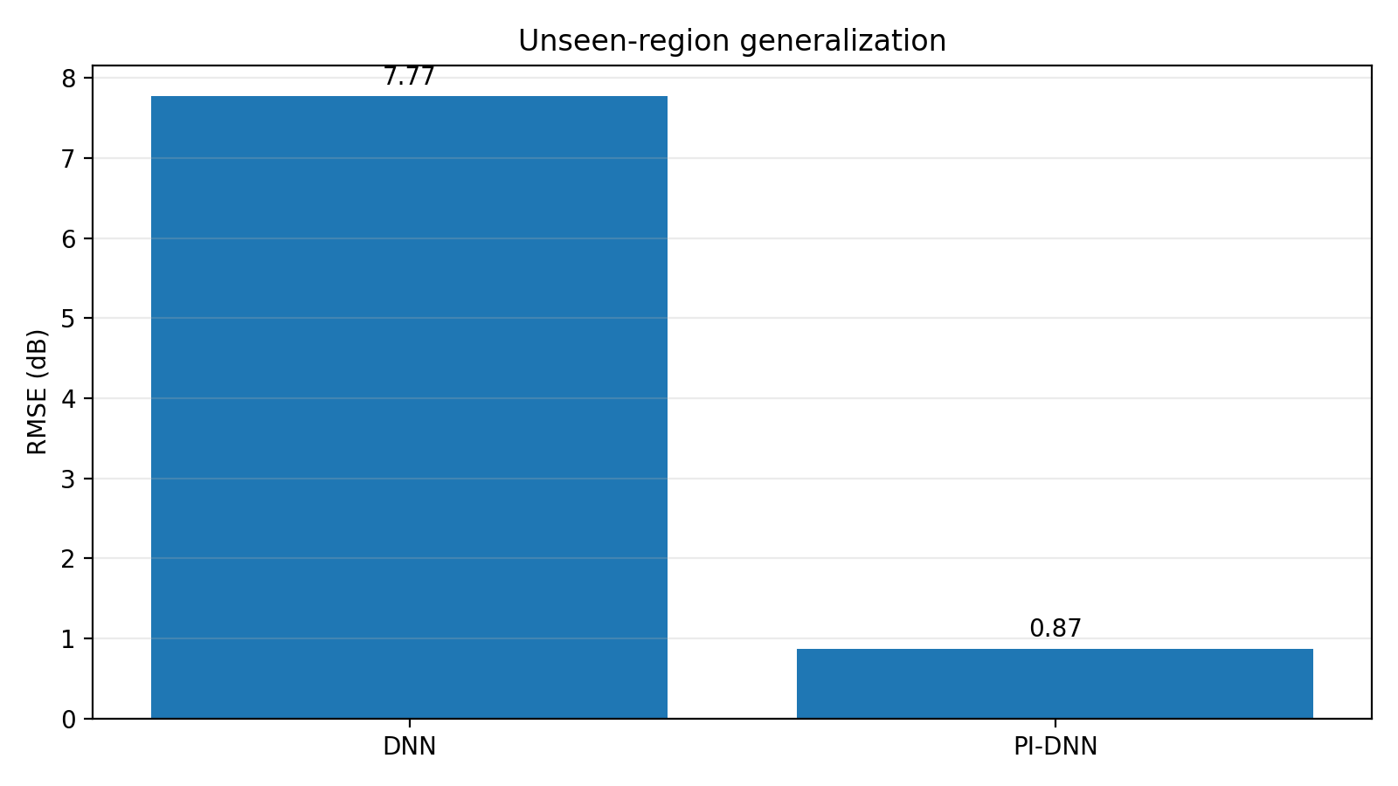
Figure 4. Unseen-region RMSE: 7.77 dB for DNN and 0.87 dB for PI-DNN.

8.1 What the Metric Difference Means
A 7.77 dB RMSE indicates that the DNN predictions are substantially less reliable on the unseen set than on labelled-region samples. The PI-DNN's 0.87 dB RMSE indicates much closer agreement with the simulated targets. The corresponding R² scores—0.626 and 0.995—tell the same story from a variance-explained perspective.

8.2 Interpretation Boundaries
- “Unseen” means outside the restricted labelled region, not outside every assumption used to build the simulator.
- The PI-DNN physics terms encode distance and frequency scaling and a free-space lower bound.
- Real terrain, antenna orientation, shadowing, and multipath can violate the simplified model or require richer constraints.
- Consequently, this result is evidence of improved simulator-domain generalization, not yet evidence of field accuracy.

9. ROBUSTNESS AND PHYSICS-WEIGHT ANALYSIS

9.1 Six Random Seeds
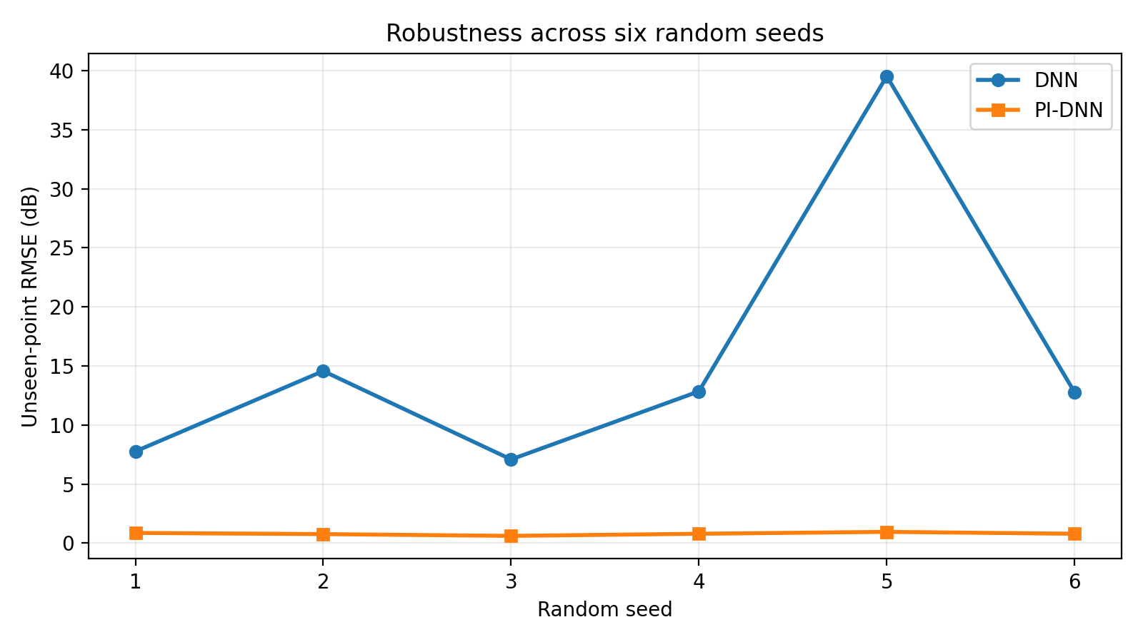
Figure 5. Unseen-region RMSE across six random seeds; values are reported in Progress Review 2.
SEED | DNN RMSE (dB) | PI-DNN RMSE (dB)
1 | 7.77 | 0.87
2 | 14.57 | 0.77
3 | 7.09 | 0.62
4 | 12.85 | 0.80
5 | 39.52 | 0.96
6 | 12.77 | 0.80
Mean ± standard deviation | 15.76 ± 12.02 | 0.80 ± 0.11

The review reports that PI-DNN has lower unseen-point RMSE in all six runs. The conventional DNN is much more variable, with one seed producing 39.52 dB RMSE. The PI-DNN remains between 0.62 and 0.96 dB in the reported runs.

9.2 Sensitivity to λ
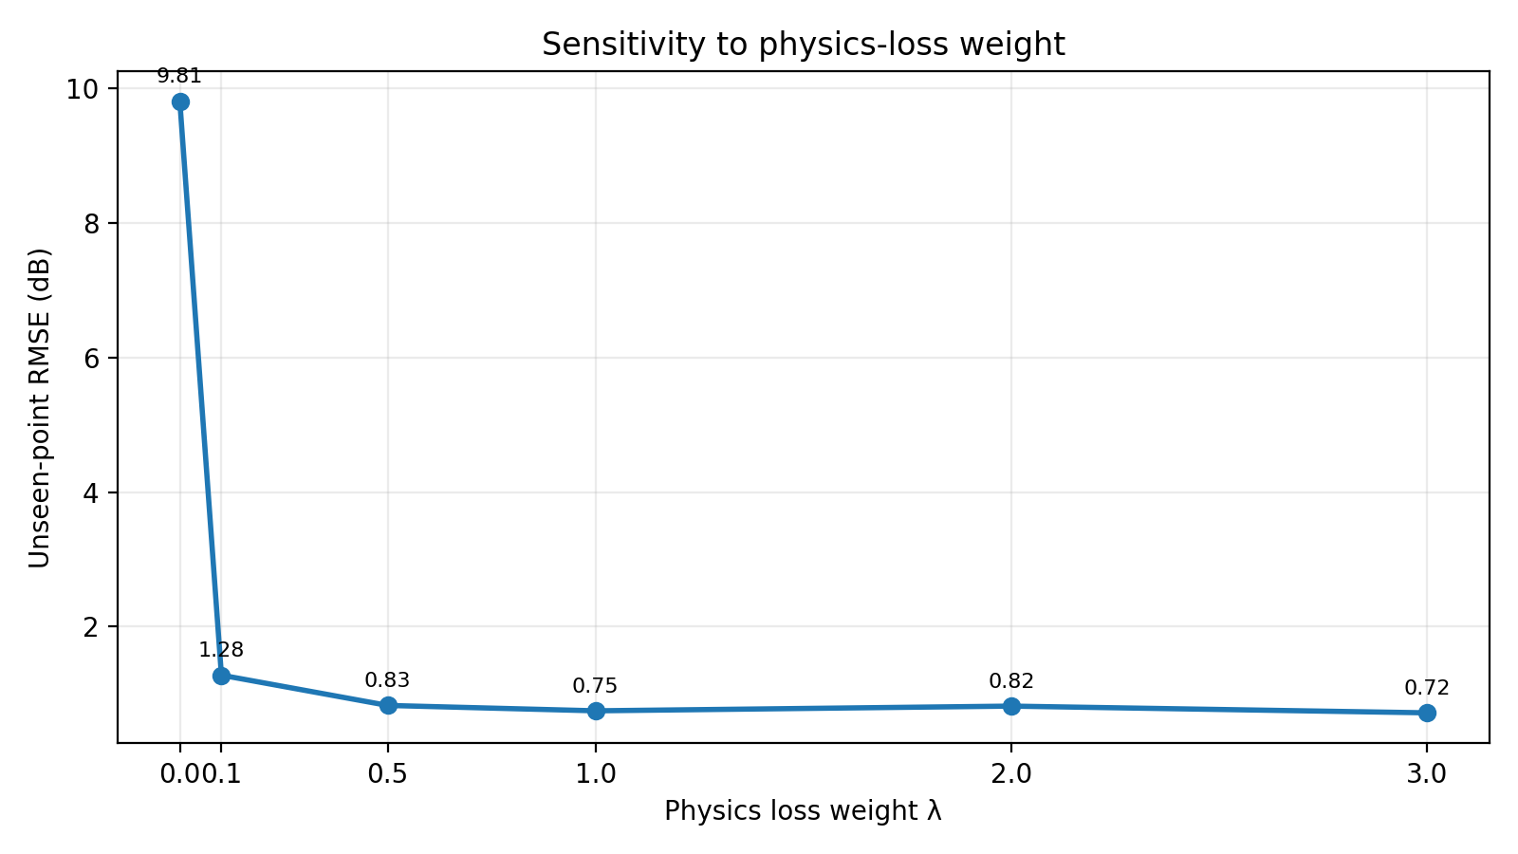
Figure 6. Reported unseen-region RMSE for the λ sweep (mean over three seeds).
The λ sweep reports RMSE of 9.81 dB at λ = 0, 1.28 dB at λ = 0.1, 0.83 dB at λ = 0.5, 0.75 dB at λ = 1, 0.82 dB at λ = 2, and 0.72 dB at λ = 3. The results suggest that adding a non-zero physics term accounts for most of the improvement in this experiment; the lowest reported value occurs at λ = 3.

10. DIGITAL TWIN AND SCENARIO STUDY

10.1 Digital Twin Features
- Interactive side-view scene with a UAV, ground station, and radio link.
- Controls for altitude, horizontal distance, carrier frequency, and transmit power.
- Predictor selection between DNN, PI-DNN, and simulator reference.
- Live readout of path loss, received power, elevation angle, LoS probability, and absolute model error.
- Link-quality label based on thresholds: Good above −80 dBm; Fair from −90 to −80 dBm; Poor below −90 dBm.

10.2 Worked Example
For the example highlighted in the review, the UAV altitude is 100 m, horizontal distance is 500 m, carrier frequency is 2.4 GHz, and transmit power is 20 dBm. The PI-DNN predicts path loss of 99.0 dB, giving estimated received power of −79.0 dBm under the stated 0 dBi antenna assumption. This falls just above the −80 dBm threshold and is labelled Good.
ALTITUDE | SIMULATOR PL (dB) | DNN PL (dB) | PI-DNN PL (dB) | PI-DNN RX (dBm) | LINK
50 m | 110.3 | 112.1 | 111.1 | −91.1 | Poor
100 m | 99.2 | 100.0 | 99.0 | −79.0 | Good
150 m | 95.1 | 94.7 | 94.7 | −74.7 | Good
200 m | 94.8 | 96.3 | 94.5 | −74.5 | Good

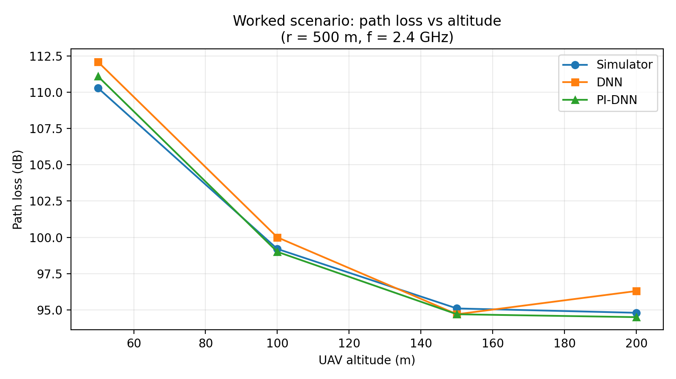
Figure 7. Worked altitude sweep at r = 500 m and f = 2.4 GHz; source values are from the review slides.
These are simulated outputs from the supplied review, not measured UAV-flight results. The table illustrates how the twin supports a quick what-if comparison as altitude changes.

11. DIGITAL TWIN WORKFLOW AND PRACTICAL USE

11.1 User Interaction Sequence
- Choose altitude and horizontal separation to position the virtual UAV relative to the ground station.
- Select the carrier frequency and transmit power for the scenario.
- Choose the prediction source: DNN, PI-DNN, or the simulator reference.
- Read predicted path loss and compute received power as transmit power minus path loss.
- Interpret the link-quality label only as a threshold-based indication, not a full network service guarantee.
- Vary one parameter at a time or sweep a range to compare channel trends.

11.2 Why a Digital Twin Helps
The twin provides a repeatable environment for comparing scenarios without needing to physically fly the UAV for each parameter setting. It can help students inspect how distance, altitude, and frequency affect a predicted link and see where a learned model diverges from the simulator. It also makes the model outputs easier to demonstrate during project reviews.

11.3 Current Boundaries
The implementation is a 2D side-view simulation with three neural-network inputs. Transmit power is used after path-loss prediction, not as a network feature. The twin is not connected to live RF equipment, does not use GPS telemetry, and does not yet model a time-varying 3D trajectory. The displayed received power assumes the antenna-gain simplification stated in the review.

12. DISCUSSION, LIMITATIONS AND ETHICS OF INTERPRETATION

12.1 Main Findings
The strongest finding is not a small improvement on training data but the contrast in the unseen region. Both models fit the labelled domain reasonably well; the PI-DNN is markedly more stable on the wider simulated domain. The six-seed experiment reinforces the observation that the physics term reduces variability in the reported simulator-based tests.

12.2 Limitations
- All numerical results in this report come from a simulated channel; there is no evidence here of validation against measured flight data.
- The propagation model simplifies the real channel. Urban clutter, terrain, moving objects, antenna orientation, polarization, Doppler effects, and frequency-selective multipath are not comprehensively represented.
- The physics constraints share the free-space core of the simulator, which can favour the PI-DNN in this particular setup.
- Performance depends on the data-generation assumptions, chosen physics terms, training procedure, and λ.
- Predictions outside the tested domain should not be treated as reliable without additional tests.
- Link-quality thresholds are illustrative and do not include receiver sensitivity, interference, bandwidth, coding, or link-budget details.

12.3 Responsible Reporting
The results are reported as supplied in the Progress Review 2 presentation and are labelled as simulation results. They should not be presented as real-world channel measurements or as a guarantee that a UAV communication link will be reliable. Future evaluation should use a public or measured dataset, keep a final test set untouched during tuning, and document the mismatch between simulated and measured channels.

12.4 Future Enhancements
Priority improvements are validation on measured or public air-to-ground data, richer LoS/NLoS and reflection physics, an ablation study that removes one physics constraint at a time, a 3D trajectory view, and evaluation across multiple environments.

13. CONCLUSION AND FUTURE WORK
This project implements a PI-DNN-based Digital Twin for UAV-to-ground wireless-channel prediction and compares it with a conventional DNN. The channel simulator combines FSPL with elevation-dependent LoS probability and environment-specific excess loss. The neural models use altitude, horizontal distance, and carrier frequency to predict path loss, while the Digital Twin derives received power from transmit power and the predicted attenuation.
In the reported default simulation, the DNN achieves 1.39 dB RMSE on labelled-region points and 7.77 dB on unseen points. The PI-DNN achieves 1.08 dB and 0.87 dB respectively. Across six seeds, mean unseen-region RMSE is reported as 15.76 dB for DNN and 0.80 dB for PI-DNN. The λ sweep indicates that a non-zero physics penalty substantially improves unseen-region performance in the current setup.
These results support the value of physical constraints for generalization within the chosen simulated environment. They do not yet prove the same performance on real UAV links because the data and physics penalties are aligned by design. The next phase should validate the model using measured or public data, enrich the propagation model, conduct ablation tests, and extend the Digital Twin to 3D trajectories.

Future Work Plan
PRIORITY | TASK | EXPECTED OUTPUT
1 | Validate against measured/public air-to-ground channel data | Evidence of real-data generalization
2 | Add richer propagation components | Improved realism under terrain and multipath
3 | Run physics-term ablation experiments | Estimate contribution of each constraint
4 | Build a 3D trajectory Digital Twin | Channel predictions along a time-varying path
5 | Package reproducible experiments | Code, parameter files, and evaluation logs

REFERENCES
[1] A. Al-Hourani, S. Kandeepan, and A. Jamalipour, “Modeling Air-to-Ground Path Loss for Low Altitude Platforms in Urban Environments,” in IEEE Global Communications Conference (GLOBECOM), 2014, pp. 2898–2904.
[2] M. Raissi, P. Perdikaris, and G. E. Karniadakis, “Physics-informed neural networks: A deep learning framework for solving forward and inverse problems involving nonlinear partial differential equations,” Journal of Computational Physics, vol. 378, pp. 686–707, 2019.
[3] 3GPP, “Enhanced LTE support for aerial vehicles,” 3GPP TR 36.777, Release 15, 2017.
[4] T. S. Rappaport, Wireless Communications: Principles and Practice, 2nd ed. Prentice Hall, 2002.
[5] Progress Review 2 presentation supplied for this project, “Physics-Informed Deep Neural Network for Digital Twin Modeling of UAV-to-Ground Wireless Channels: Implementation, Digital Twin & Results,” 2026–27.

Source and Results Note
The quantitative metrics, six-seed RMSE values, λ-sweep values, and worked-example scenario in Sections 7–10 are transcribed from the supplied Progress Review 2 slide deck. Graphs in this report visualize those reported values. No additional experimental runs or raw point-level scatter data were available in the supplied materials; therefore, the report does not invent point-level actual-versus-predicted samples or detailed epoch-by-epoch loss curves.
Prepared for the Machine Learning course 25SC2107E, academic year 2026–27.

